# Diagnosis of Diabetes using an fis

IMAT3406 | Fuzzy Logic & KBS | Emily Simpson | P16208224 | 2018 – 2019

## introduction

Diabetes has been known in the past as a disease that had no cures, but in today’s age the number of people being diagnosed with diabetes is sky-rocketing. Diabetes is a condition in which the body cannot process food for use as energy, there in effect affects the bodies use of blood sugar (glucose). Diabetes can be classified into general categories;

* Type 1: due to autoimmune β-cell destruction, leading to absolute insulin deficiency.
* Type 2: due to a progressive loss of β-cell insulin secretion frequently on the background of insulin resistance.
* Gestational diabetes mellitus (GDM): diabetes diagnosed in the second or third trimester of pregnancy that was not clearly overt diabetes prior to gestation.

Diabetes diagnosis is based on plasma glucose criteria, either the fasting plasma glucose (FPG) or the 2-h plasma glucose (2-h PG) value after a 75-g oral glucose tolerance test (OGTT) or A1C criteria. They equally appropriate for diagnostic testing. The same tests may be used to screen for and diagnose diabetes and to detect individuals with prediabetes. Classification of Diabetes defined by IFG as FPG levels between 100 and 125 mg/dL (between 5.6 and 6.9 mmol/L) and IGT as 2-h PG after 75-g OGTT levels between 140 and 199 mg/dL (between 7.8 and 11.0 mmol/L). If left undiagnosed it can lead to many complications which in the end can be fatal. So early diagnosis is key, which is where artificial intelligence has made its mark. [1, 4]

## literature review

Fuzzy Logic is a system used to develop decision making intelligent systems, the working of Fuzzy Inference System follows a crisp input converted in to fuzzy by using the fuzzification method. Fuzzy sets can contain only a partial degree of membership. To determine the membership function, the function can be set a value, assigned to the elements of the universal set which fall within a specific range therefore will indicate membership grade in the Fuzzy set of question. The behaviour of a fuzzy system is characterized by a set of linguistic rules based on expert knowledge, using both antecedents and the consequents, in other words conditional statements, a rule is built based on inputs in membership function. The rule base and database are referred to as the knowledge base. Defuzzification is converting a fuzzy value to the real-world value which is the output. The notion of a fuzzy set from the ordinary set is characterized by a membership function taking the values of either 0 or 1, representing degrees of belonging to the fuzzy set. [2-4]

Fuzzy logic expert systems used in medical examination are of great importance, providing an exact evaluation report of medical data provided to the system. These types of system provide an instant, simple method of medical examination and/or diagnosis. These systems give results based on facts built which are acquired from experts and authorities in the field. [6] The medical diagnosis system can make the result of diagnosis and treatment scheme more reasonable. As an FIS considers known facts which are applied to variables, used to construct outputs established from set of rules. Evaluation of rules is done after the collection of observed data. Identification of pattern and suggestion of problem linked with that pattern is given when the rules are logically satisfied. [5]

The use of expert systems and artificial intelligence techniques in disease diagnosis has been gradually increasing over the years. One method for diagnosing diabetes is by using Fuzzy logic controller which was developed using an Mamdani type fuzzy logic to observe the blood glucose level. Correlation in Fuzzy Logic was proposed to overcome the overlapping problem between each function when plotting the membership function in a fuzzy expert system for diagnosis of diabetes. A fuzzy expert system has been developed to give percentage risk for a person to get diabetes. An expert system involves the collection and encoding of rules, together with an inference engine for evaluating the rule base for a given set of inputs. There are four steps involve in this system development; determine fuzzy set, build membership function, if-then rule development and defuzzification. [4]

Another method for diagnosing diabetes using Fuzzy based expert system is using an Adaptive Nero-Fuzzy Inference System (ANFIS). This system is difference lies in the membership function parameters as they are extracted from a data set that describes the system behaviour. Making this model less reliant on expert knowledge. Many authors believe that using a neural network increases the flexibility in modelling and accuracy in predictions as well as their capacity to find solutions from limited or incomplete data sets. It has been shown that neural networks can combine data of a different nature on one complete system. [7]

P. Dagar et al. Created a medical diagnosis system using a Fuzzy Inference System in MATLAB, his inputs were all symptoms of different diseases and his outputs being several diseases. Using the rule editor to compute each characteristic of each variable to the outputs in response to the inputs. The purpose of this was to help a patient perform a self-analysis, therefore taken the burden of doctors and health care providers. [6]

A.A Abdullah et al. created a Fuzzy Expert System to give a percentage of risk for a person to get diabetes. Used inputs from a medical practitioner’s journal using the total of 17 inputs and 6 outputs. Using inputs like age, BMI, cigarettes intake, glucose level. Triangular membership functions were used to showcase variables from the inputs. The percentage risk was divided into 6 categories giving a clear and concise result. This system is already widely used as it can give specific decision in a shorter time frame. Therefore, providing a support system to improve treatment and giving an advantage to preventing the disease. [4]

The advantages of using a Fuzzy based system to diagnose diabetes means that the system can be widely used as it can give results in a shorter time frame. Equally, the system can give more accurate results since the inputs and outputs give more a specific indication of the main cause for the diagnosis and the best conclusion for treatment. This also means that medical practitioners and professionals can use this software as a support system to improve treatment while taking further steps to preventing this disease.

## The problem

The problem my system is trying to address is the efficiency in which the general public is tested for diabetes, mainly to reduce the amount of time waiting for the results. The papers that I have researched are all based on one major theme that of wanting to tackle the problem of undiagnosed diabetes as well as quicker and more accurate test results. These papers all have variations and interpretations of the data and variables they use, but all have similar outputs due to using the logical approach using medical research to classify and diagnose. To solve this problem the best conclusion is to find the quickest and logical way about it, and with early diagnosis will help save lives. The way I have chosen to overcome the problem is that I will be tackling it in a related way as I will be using some of the variables used in other systems and my outputs will contain the same information. As well as using a rule base to calculate outputs using the knowledge gained from medical research to give a more accurate and reliable interpretation within my output variables.

## the system

The system was designed as a Mamdani Style System with four inputs and one output: Age, BMI (Body Mass Index), DBP (Diastolic Blood Pressure), FPG (Fasting Plasma Glucose) and the output of Diabetes Likelihood (%). The rule base was created from all rules being in the form of IF a is A AND b is B AND x is X AND y is Y THEN z is Z. The values inputted for variables a, b, x, y was drawn from a Microsoft Excel file feeding the programme with data. This fuzzy logic system in construction will determine a basic percentage of the likelihood of diabetes. Using the Mamdani style system will ensure that the variance in each variable will remain different allowing a varied system but with more accurate results. I noticed when researching I found that other systems didn’t just diagnose diabetes, they were systems which used many input variables and gave outputs diagnosing other diseases, with similar symptoms. I cherry picked the symptoms that where needed to fully diagnose the condition, bearing in mind I wanted to output the percentage of likelihood of having diabetes.

Sets:

Age: The range of the first set will range between 0 to 110 years, this is due to average living age, obviously there are occasions where people do live past 110 but in this case, they will be discounted. This set will be grouped by four membership functions, all four membership functions use the Gaussian Membership function; Young (15 0), Middle (10 40), Old (10 70), Very Old (15 110). Using this membership

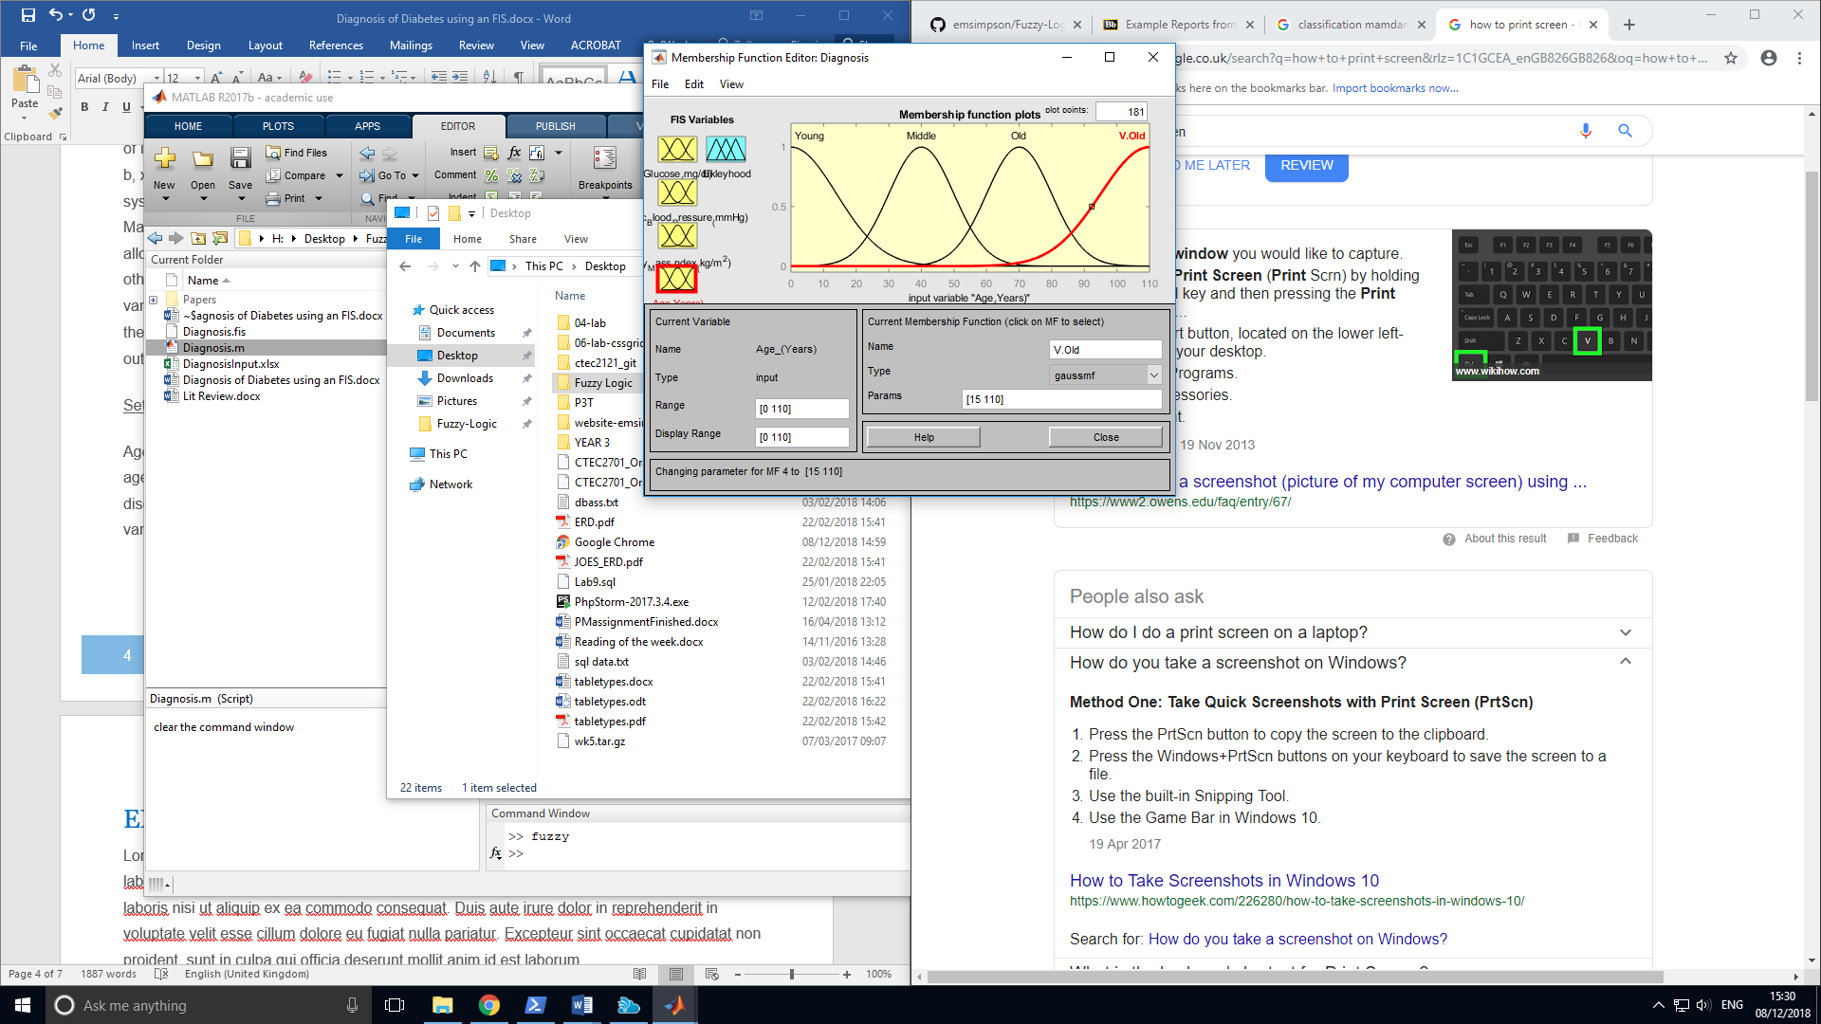

Figure 1

## experimental design and evaluation

Lorem ipsum dolor sit amet, consectetur adipiscing elit, sed do eiusmod tempor incididunt ut labore et dolore magna aliqua. Ut enim ad minim veniam, quis nostrud exercitation ullamco laboris nisi ut aliquip ex ea commodo consequat. Duis aute irure dolor in reprehenderit in voluptate velit esse cillum dolore eu fugiat nulla pariatur. Excepteur sint occaecat cupidatat non proident, sunt in culpa qui officia deserunt mollit anim id est laborum.

## critical reflection

Lorem ipsum dolor sit amet, consectetur adipiscing elit, sed do eiusmod tempor incididunt ut labore et dolore magna aliqua. Ut enim ad minim veniam, quis nostrud exercitation ullamco laboris nisi ut aliquip ex ea commodo consequat. Duis aute irure dolor in reprehenderit in voluptate velit esse cillum dolore eu fugiat nulla pariatur. Excepteur sint occaecat cupidatat non proident, sunt in culpa qui officia deserunt mollit anim id est laborum.

## Conclusion

Lorem ipsum dolor sit amet, consectetur adipiscing elit, sed do eiusmod tempor incididunt ut labore et dolore magna aliqua. Ut enim ad minim veniam, quis nostrud exercitation ullamco laboris nisi ut aliquip ex ea commodo consequat. Duis aute irure dolor in reprehenderit in voluptate velit esse cillum dolore eu fugiat nulla pariatur. Excepteur sint occaecat cupidatat non proident, sunt in culpa qui officia deserunt mollit anim id est laborum.

## References

[1] American Diabetes Association, 2017. 2. Classification and diagnosis of diabetes. Diabetes care, 40(Supplement 1), pp.S11-S24.

[2] Ephzibah, E.P., 2011. Cost effective approach on feature selection using genetic algorithms and fuzzy logic for diabetes diagnosis. *arXiv preprint arXiv:1103.0087*.

[3] Lee, C.C., 1990. Fuzzy logic in control systems: fuzzy logic controller. I. *IEEE Transactions on systems, man, and cybernetics*, *20*(2), pp.404-418.

[4] A. A. Abdullah, N. S. Fadil and W. Khairunizam, "Development of Fuzzy Expert System for Diagnosis of Diabetes," 2018 International Conference on Computational Approach in Smart Systems Design and Applications (ICASSDA), Kuching, 2018, pp. 1-8.

[5] Manish Rana, & Sedamkar R.R., (2013). “Design of Expert System for Medical Diagnosis Using Fuzzy Logic”. International Journal of Scientific & Engineering Research, Volume 4, Issue 6, June-2013, pg. 2914-2921 ISSN 2229-5518.

[6] Preety Dagar, Aman Jatain, Dr. Deepti Gaur (2015). “Medical Diagnosis System Using Fuzzy Logic Toolbox”. International Conference on Computing, Communication and Automation (ICCCA2015). Pg.193-197.

[7] Übeyli, E.D., 2010. Automatic diagnosis of diabetes using adaptive neuro‐fuzzy inference systems. Expert Systems, 27(4), pp.259-266.

## appendices